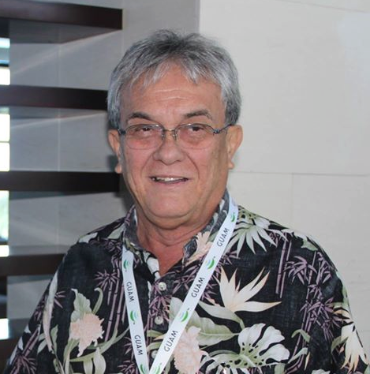

*Photo: Keynote speaker, Tony deBrum, Republic of the Marshall Islands. See other side for additional program information.*

Gather at Livermore Lab

Tuesday, August 9 at 8 AM

Nagasaki Day 2016

***Music, speakers, drummers, art and more, followed by***

***a short procession to the Livermore Lab gates where***

***those who choose will peacefully risk arrest***

**Come to the Livermore nuclear weapons laboratory’s northwest corner, at Vasco & Patterson Pass Roads, in Livermore.** There will be parking set up at the rally site and vanpools from the Dublin-Pleasanton BART station (you must call 925-443-7148 in advance to reserve a seat).

On the 71st anniversary of the U.S. atomic bombings of Hiroshima and Nagasaki, we invite all who seek peace and justice to gather at the location where scientists are developing new nuclear weapons for the U.S. arsenal. Each new weapon involves “upgraded” features able to cause unimaginable devastation anywhere on Earth. Livermore Lab’s budget reveals that 86% of its funding is for nuclear weapons.

**Stand with Hibakusha (A-bomb survivors), Pacific Islanders and others harmed by nuclear technology.** This event is part of the global *“Chain Reaction: Breaking Free from Nuclear Weapons.”*

Co-sponsored by American Friends Service Committee, Asian Americans for Peace & Justice, Catholic Workers, East Timor Religious Outreach, Ecumenical Peace Institute, Livermore Conversion Project, Marin Peace & Justice Coalition, Mt. Diablo Peace & Justice Center, Nafsi ya Jamii, Newman Nonviolent Peacemakers/Fr. Bill O’Donnell Social Justice Committee, Modesto Peace/Life Center, No Nukes Action Committee, NorCal District-Communist Party USA, Pacific Life Community, Pax Christi-NorCal, Peace Action, Physicians for Social Responsibility-SF Bay Area, San Jose Peace & Justice Center, Social Justice Center of Marin, Tri-Valley CAREs, Veterans For Peace-Chapter 162, Western States Legal Foundation.

***Additional co-sponsors welcome! Contact Livermore Conversion Project, PO Box 28119, Oakland, CA 94604***

**DISARM NOW:**

**We Stand with Nuclear Survivors for Global Justice**

In conjunction with the August 9 action…

**Del Valle Regional Park**

**in Livermore**

**August 8, 2016**

**WHAT:** A group camp out in beautiful Del Valle Regional Park the night before the August 9th Action at Livermore Lab; appropriate for experienced campers of all ages.

**WHEN:** Monday, August 8, 2016 - Check in 2 PM - 9 PM. At 7 AM the next morning we will caravan to the Lab for the event. (Note: the park gate opens at 5 AM.)

**WHERE:** Eagles’ View group camp at Del Valle Regional Park & Reservoir (swimming), located on Del Valle Road off Mines Road, about 9 miles outside of Livermore.

**PARKING:**  Limited parking at the campground, carpooling is suggested.

**COST:** $10 per person. No additional charge for parking. Bring a water container.

**DETAILS:** Scott Yundt at Tri-Valley CAREs: (925) 443-7148 or [scott@trivalleycares.org](mailto:scott@trivalleycares.org)

**RSVP REQUIRED • Musical instruments welcome • No pets • No alcohol**

**The Livermore Conversion Project Nonviolence Guidelines\***

**We agree to abide by the following guidelines in all of today’s actions:**

* **We will be open and respectful to everyone we meet;**
* **We will not use verbal or physical violence;**
* **We will not destroy property;**
* **We will not bring drugs or alcohol, except for medicinal purposes;**
* **We will not bring weapons;**
* **We will not run, which can cause panic;**
* **If arrested, we will not resist;**
* **If legal consequences follow our actions, we will treat all those we encounter in the process with openness and respect.**

**\*Adopted by consensus of the planning group for the Aug. 9, 2016 actions at Livermore Lab**

*Chizu Hamada (4th from left) and No Nukes Action at Livermore 2015*

**8 AM AUGUST 9th PROGRAM SUMMARY**

**Tony deBrum**, our keynote speaker and special guest from the Marshall Islands, will discuss the U.S. nuclear bomb tests detonated there and the current, courageous “Nuclear Zero” lawsuits against the U.S. and 8 other nuclear weapons states for their failure to disarm. **Nobuaki Hanaoka**, a Nagasaki A-bomb survivor, will share his experience and insights. Speakers, music and drummers will be followed by a short march to the West Gate for a Japanese Bon dance and nonviolent direct action.

