**LIVING FOR 32 (42 minutes)**

**Colin Goddard’s went from gunshot survivor to advocate with Brady Campaign after being shot four times during Virginia Tech shooting that left 32 dead and 17 wounded.**

**Discussion led by Christopher R. Moylan**

**Sunnyvale council member key in getting controversial Gun Control Measure C on the ballot and Passed!**

**Learn how we can pass Gun Control in our cities.**

**Hosted by UUCPA Week of Nonviolent Action**

**Film & Discussion**

**HOW CAN we CONTROL GUN VIOLENCE?**

Sunday, August 24th 4:00 – 6:00 pm

**Fireside Room**

**Unitarian Universalist Church of Palo Alto**

**505 East Charleston Road, Palo Alto 94306**

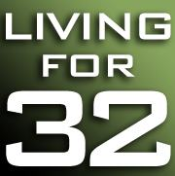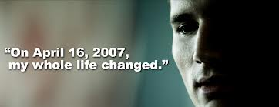

**LIVING FOR 32 (42 minutes)**

**Colin Goddard’s went from gunshot survivor to advocate with Brady Campaign after being shot four times during Virginia Tech shooting that left 32 dead and 17 wounded.**

**Discussion led by Christopher R. Moylan**

**Sunnyvale council member key in getting controversial Gun Control Measure C on the ballot and Passed!**

**Learn how we can pass Gun Control in our cities.**

**Hosted by UUCPA Week of Nonviolent Action**

**Film & Discussion**

**HOW CAN we CONTROL GUN VIOLENCE?**

Sunday, August 24th 4:00 – 6:00 pm

**Fireside Room**

**Unitarian Universalist Church of Palo Alto**

**505 East Charleston Road, Palo Alto 94306**

